IHE Workitem Proposal (Short)

# Proposed Work Item: Nursing Framework for the Patient’s Continuum of Care (NFPCC)

Proposal Editor: Emma Jones, Denise Downing

Work Item Editor: Emma Jones, Denise Downing

Date: August 4, 2011

Version: Version 1

Domain: Patient Care Coordination (PCC)

# The Problem

This profile is in response to the IHE PCC request for clarification of the patient continuum of care following Nursing Process. The relationships and interdependencies of existing nursing profiles or those under development are not well understood. Nursing data has not been clearly defined in the aggregation and communication of nursing care across health care settings. The existing profiles and those under development, define diverse yet at times overlapping or interconnected aspects of nursing care. The goal of the NFPCCC profile is to provide a framework to integrate past and future profiles.

In its first phase, this collaborative project will describe the collection of nursing data and nursing workflows as it relates to the exchange of nursing data across the care continuum. The initial proposal will be comprised of exchanges between nurses and other providers during any episode of care for the patient. The scope of the project is to provide an initial interoperable nursing process workflow with discrete data elements that can be shared across information systems ***within and*** across care settings without regard for vendor.

# Key Use Case

Mike Jones is a 72 y/o followed by his primary care provider for joint pain and difficulty ambulating. He is referred to an orthopedic specialist to evaluate severe osteoarthritis and determines that Mr. Jones needs surgery. He is seen for a preadmission visit prior to a left total knee replacement at Memorial Hospital. Mr. Jones is admitted and has surgery as scheduled. Post-op course is documented in an In-Patient EMR and Mr. Jones is discharged to a rehab facility for short term therapy. He is subsequently discharged to home with home health care and follow up post-op care with his specialist and primary care providers.

**Current flow:** Primary Care physician fills out paper referral. Primary care office nurse contacts orthopedic specialist office via telephone. Patient arrives for orthopedic specialist visit. Specialist nurse fills out paperwork including medical/surgical history, allergies and medications which is reviewed, confirmed and modified as needed by the provider. Orthopedic Specialist determines need for surgery. Request is faxed to local hospital to schedule surgery. Hospital contacts Mr. Jones and schedules pre-admission appointment. Mr. Jones meets with RN coordinator who interviews him and reviews his health history, plan of care and updates his information in the facility EMR. Mr. Jones has a left total knee replacement. When patient is stabilized, it is determined he is a candidate for short term rehabilitation. Discharge summary including nursing data is sent with patient to rehabilitation facility. Subsequently the patient is discharged to home with the support of home health services and follow up ambulatory care.

**Proposed flow:** Patient is seen in multiple care settings beginning with primary care, then specialist care, acute care setting, and extended care setting followed by discharged to home setting. At each care setting the nursing process is applied and documented in the applicable electronic medical record (EMR). The nursing data is electronically shared across all care settings. The nursing process documentation (NPD) includes: Assessment, Diagnosis, Outcomes Identification (goals), Planning, Implementation, Evaluation (of diagnosis). These relationships are demonstrated in figure 1 below.

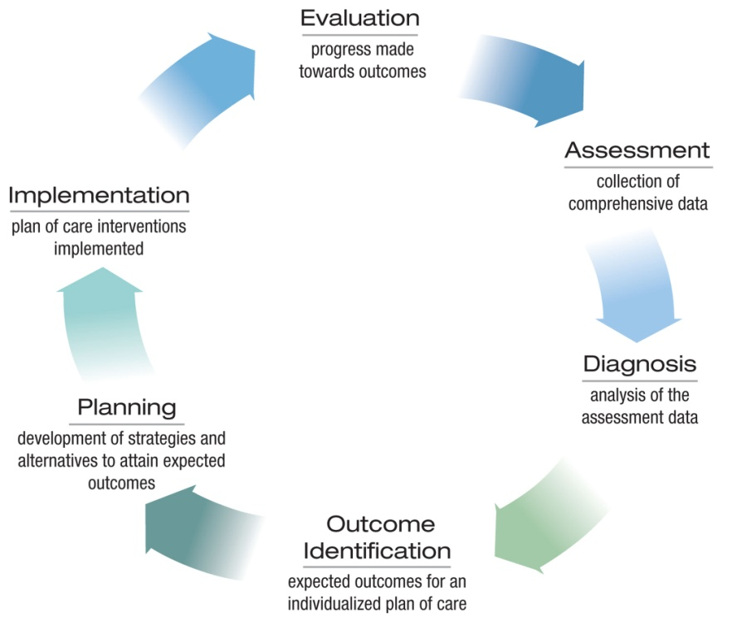

**Figure 1:** adapted from the 2004 ANA Scope and Standards of Practice

# Standards & Systems

NURSING TERMINOLOGY

SNOMED, LOINC, RxNorm, DICOM

XDS-MS, CCR, HL7 CDA

HL7 Patient Care

FSA, PPOC, ENS Profiles

XPHE, EDR, XDS-MS profiles

XDS/XDR/XDM Cross-community and Cross enterprise Document Sharing

PIX Patient Identity Cross Reference

PDQ Patient Demographics Query

ATNA Audit Train and Node Authentication

CT Consistent Time

XD-Lab profile, XDC-I profile, XDS

# Discussion

The NFPCC is a profile describing the exchange of nursing data to support safe, timely and high quality patient care across care settings. The profile sequences existing profiles (i.e., PPOC, e-Nursing Summary) that support the exchange of nursing data between patient, caregivers and healthcare providers. The NFPCC profile will support consistent documentation of nursing practice showing the impact on quality metrics and patient outcomes across all care settings. The electronic sharing of nursing data provides the opportunity to:

* improve care quality, safety, and efficiency by providing nursing data at the point of care;
* increase access to up-to-date nursing data electronically for patients and their families;
* improve care coordination by providing access to nursing data in a timely manner;
* improve population and public health by providing nursing data that is accurate and complete;
* reduce disparities in nursing data;
* support research opportunities.